**Topic name : Static Routing**

**Submitted by:**

**MD Jahidul Islam**

[**Jahidislam1204.bd@gmail.com**](mailto:Jahidislam1204.bd@gmail.com)

**01854101988**

**Submitted to**

**Md Jahirul Islam**

**CSL, Kuril**

**Static Routing:**

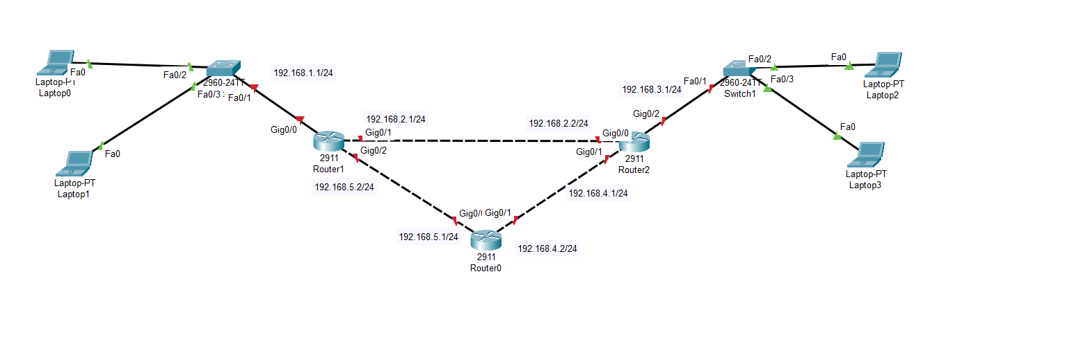

**Ip Configure: For Router 1**

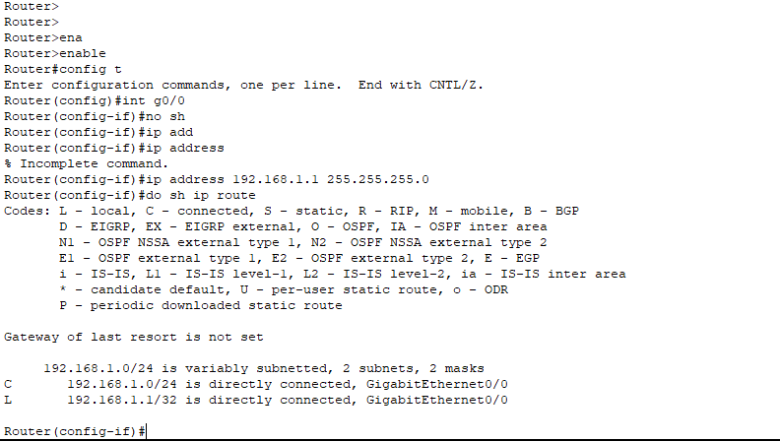

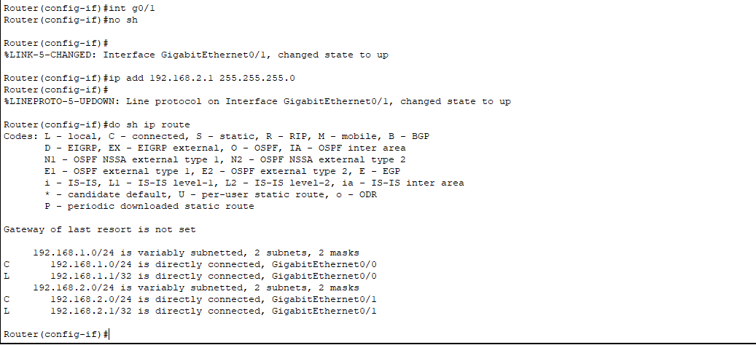

**For Router2:**

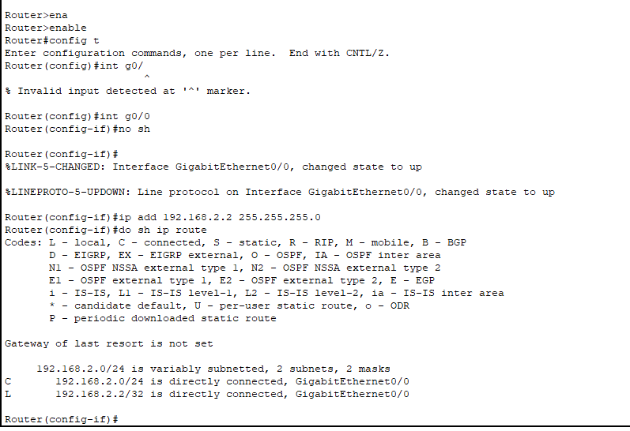

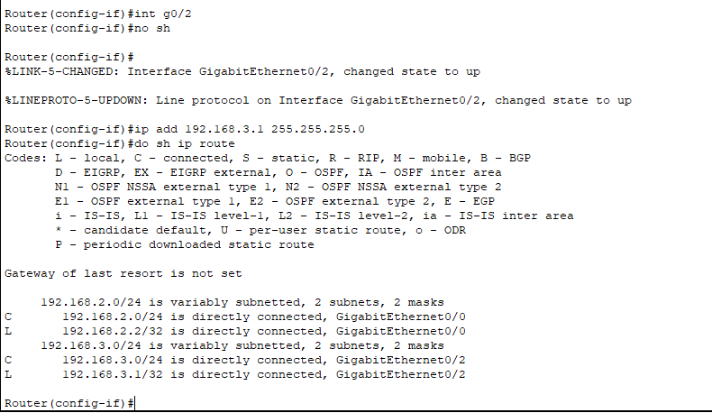

**After Config IP in router1 and router2**

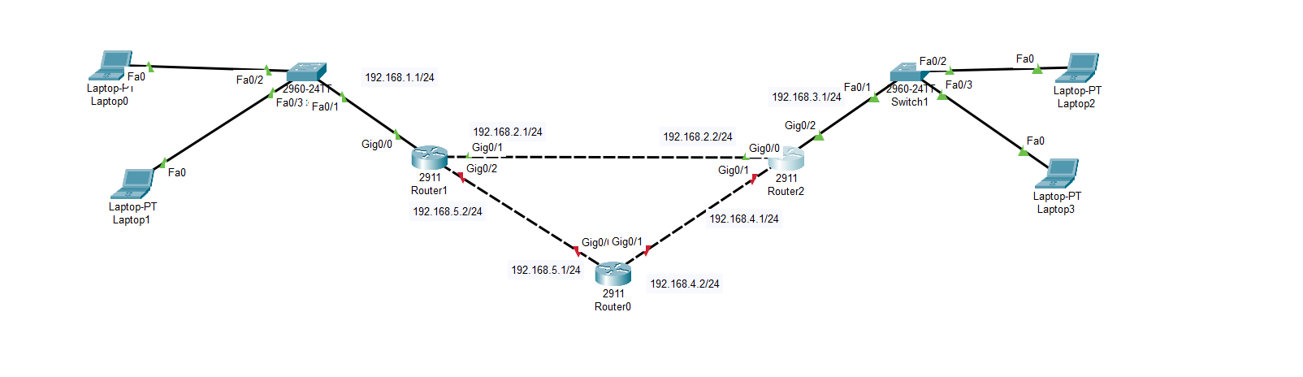

**To recognized the network path for both router:**

**For router 1:**

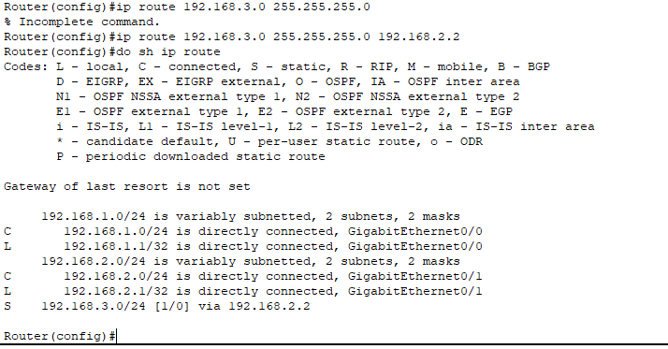

**For router2:**

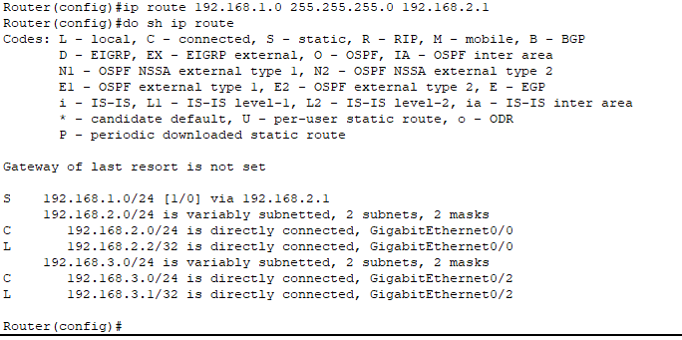

**Output: Succesfull**



**Config router0:**

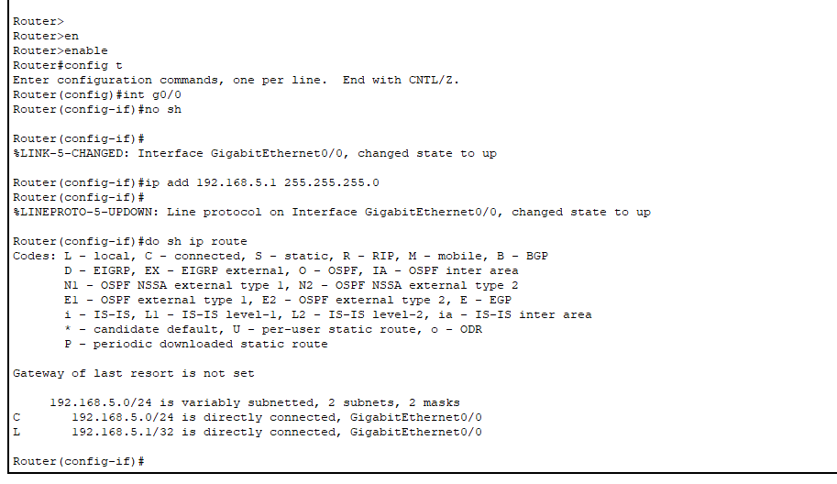

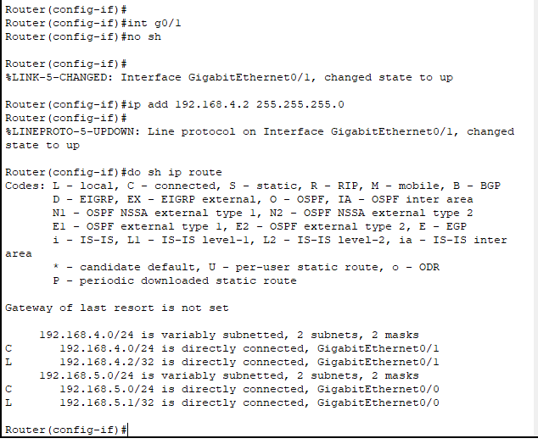

**To recognized the network path for router0:**

